How to Install and Configure BloodHound on Kali Linux
22 January 2021
Kali Linux
In our this article we are going to learn how to install BloodHound on our Kali Linux system. BloodHound is going to be extremely useful when we're looking to enumerate an active directory environment. It is very important tool for both Red-Team and Blue-Team.
This application developed with one purpose: to find relationships within an Active Directory (AD) domain to discover attack paths. BloodHound uses graph-theory so it is easy to find the shortest path for an attacker.

BloodHound identifies the attack paths in an corporate network that can be exploited for a pen tester (or a red team) to be able to gain domain admin permissions.

Install BloodHound on Kali Linux
BloodHound is now available on Kali Linux repository. To install BloodHound on Kali Linux first we need to install it from Kali Linux repository by using following command:
sudo apt-get install bloodhound
It will take some time to download and install depending on our internet speed and system performance.

Configure BloodHound on Kali Linux
We can't just install it and run bLoodHound. We need to configure it before running. First of all we need to set the permission by using following command:
sudo chown -R kali /usr/share/neo4j
Then we run the neo4j console by using following command:
neo4j console
Then the console will start as we can see in the following screenshot:
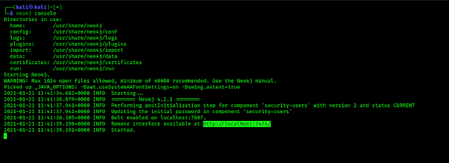
Localhost link is highlighted
We can see it is started and we can see the web interface is available on the highlighted localhost link. We need to navigate to the link first from our browser and we got the web interface as following screenshot:
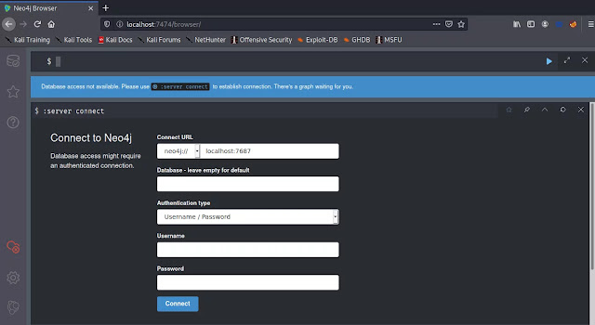
Here we need to create a new username and password, with the default password BloodHound will not open. Before that we need to login this web based interface using default password.
The default credential for BloodHound will be Username: neo4j Password: neo4j
We need to log in using the default credential and leave the other fields as it is. After login we can see fields to reset the default password as following screenshot:
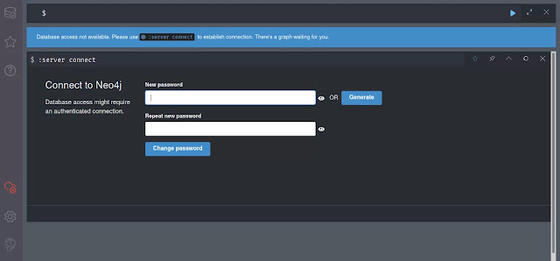
Here, we can choose a new password and repeat the password to confirm. It will create a new password for user neo4j. We can see it on the following screenshot:
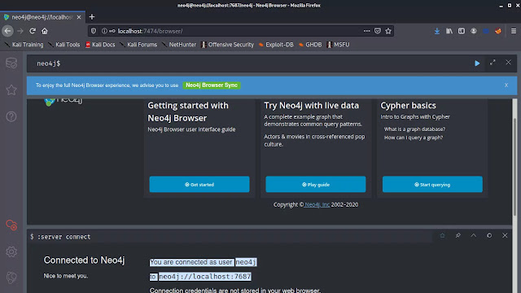
In the above screenshot we can see that we have changed the password for the user neo4j on bloodhound web interface, now it's time to open the BloodHound.

Running BloodHound on Kali Linux
We leave the the terminal running the neo4j console as it is, and open another terminal and run following command to start BloodHound:
bloodhound
This will open the BloodHound login panel as the following screenshot:
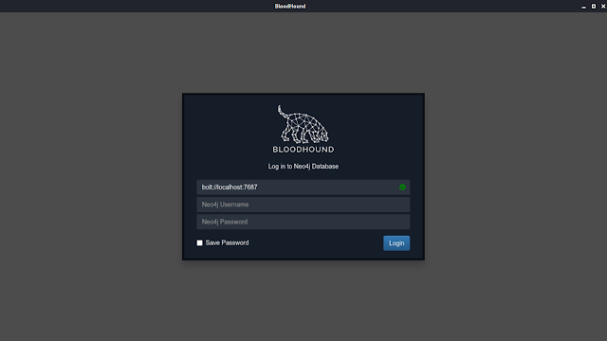
Here we need to confirm the green ✅ sign on the first field. Then we can login using username neo4j and the password we have chosen in previous step. After click on login we will be in the main screen of BloodHound as following screenshot:
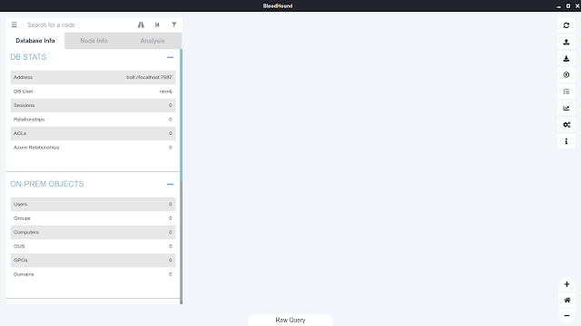
This is how to install BloodHound on Kali Linux.

Uninstall just bloodhound
sudo apt-get remove bloodhound
Which will remove just the bloodhound package itself.

Uninstall bloodhound and its dependencies
sudo apt-get remove --auto-remove bloodhound
This will remove the bloodhound package and any other dependant packages which are no longer needed.

Purging your config/data too
If you also want to delete your local/config files for bloodhound then this will work.
Caution! Purged config/data can not be restored by reinstalling the package.
sudo apt-get purge bloodhound
Or similarly, like this bloodhound
sudo apt-get purge --auto-remove bloodhound

Bloodhound working

powershell -ep bypass
./ADRecon.ps1 -outputDir All -ADRecon -Output Type HTML

import-module .\Sharphound.ps1
Invoke bloodhound -Collection Method All -Verbose -Domain pentesting

You can confirm the the info by using powerview for all acl
Get-ObjectAcl – Sam AccountName Hidden

What if we want to check AD Ridghts or Generic Write permission

Get -ObjectAcl -SamAccountName Hidden | ? {$_.ActiveDirectoryRigths -match ‘Generic Write’)}

let us say we verified that we have generic write access , now what we can do

net user student1 /domain

Add-Domain Group Member – Identify ‘Hidden’ -Members ‘student1’ -Domain ‘pentesting’

net user student1 /domain

Get-DomainGroup -Name hidden

I am running version 4.0.7. Many answers I found on the internet state "Delete /data/dbms/auth". That does not work for 4.0.7, that file does not exist.
I followed these instructions, and they worked. https://neo4j.com/docs/operations-manual/current/configuration/password-and-user-recovery/
Mainly do this:
- Stop neo4j if its running
- edit /etc/neo4j/neo4j.conf, and uncomment dbms.security.auth_enabled=false
- connect to the database and run
ALTER USER neo4j SET PASSWORD 'mynewpass'; :exit
- Stop neo4j
- comment out the dbms.security.auth_enabled=false
- start neo4j

If you want to send sharphound then send the one having same version as that of bloodhound you are running

usr/lib/bloodhound/resources/app/collectors

sharphound.exe located there

SharpHound
SharpHound is the official data collector for BloodHound. It is written in C# and uses native Windows API functions and LDAP namespace functions to collect data from domain controllers and domain-joined Windows systems.
Download the pre-compiled SharpHound binary and PS1 version at https://github.com/BloodHoundAD/BloodHound/tree/master/Collectors
You can view the source code for SharpHound and build it from source by visiting the SharpHound repo at https://github.com/BloodHoundAD/SharpHound3

Basic Usage
You can collect plenty of data with SharpHound by simply running the binary itself with no flags set:
C:\> SharpHound.exe
SharpHound will automatically determine what domain your current user belongs to, find a domain controller for that domain, and start the “default” collection method. The default collection method will collect the following pieces of information from the domain controller:
- Security group memberships
- Domain trusts
- Abusable rights on Active Directory objects
- Group Policy links
- OU tree structure
- Several properties from computer, group and user objects
- SQL admin links
Additionally, SharpHound will attempt to collect the following information from each domain-joined Windows computer:
- The members of the local administrators, remote desktop, distributed COM, and remote management groups
- Active sessions, which SharpHound will attempt to correlate to systems where users are interactively logged on
When finished, SharpHound will create several JSON files and place them into a zip file. Drag and drop that zip file into the BloodHound GUI and the interface will take care of merging the data into the database.

The Session Loop Collection Method
BloodHound uses graph theory to find attack paths in Active Directory, and the more data you have, the more likely you are to find and execute attack paths successfully. Much of the data you initially collect with SharpHound will not likely change or require updating over the course of a typical red team assessment - security group memberships, Active Directory permissions, and Group Policy links change relatively rarely. That data can be collected one time, and not again.
User sessions are different for two reasons:
1. Users, especially privileged users, log on and off different systems all day, every day. How many systems does a typical help desk user or server admin log into on any given day?
2. The way SharpHound’s data collection works necessitates scanning the network several times to get more complete session information. Scannning the network one time for user sessions may give you between 5 and 15% of the actual sessions on the network.
When you use the path finding function query in BloodHound to find a path between two nodes and see that there is no path, 9 times out of 10 this is because BloodHound needs more session data.
SharpHound’s Session Loop collection method makes this very easy:
C:\> SharpHound.exe --CollectionMethod Session --Loop
This will run SharpHound’s session collection method for 2 hours, generating a zip file after each loop ends. When done, collect all the zip files and drag and drop them into the BloodHound GUI.
If you would like to specify a different loop time, use the –Loopduration flag with the HH:MM:SS format to specify how long you want SharpHound to perform looped session collection for. For example, if you want SharpHound to perform looped session collection for 3 hours, 9 minutes and 41 seconds:
C:\> SharpHound.exe --CollectionMethod Session --Loop --Loopduration 03:09:41

Running SharpHound from a Non Domain-Joined System
While not an officially supported collection method, and not a colletion method we recommend you do, it is possible to collect data for a domain from a system that is not joined to that domain. To do so, carefully follow these steps:
1. Configure your system DNS server to be the IP address of a domain controller in the target domain.
2. Spawn a CMD shell as a user in that domain using runas and its /netonly flag, like so:
C:\> runas /netonly /user:CONTOSO\Jeff.Dimmock cmd.exe
You will be prompted to enter a password. Enter the password and hit enter.
3. A new CMD window will appear. If you type whoami, you will not see the name of the user you’re impersonating. This is because of the /netonly flag: the instance of CMD will only authenticate as that user when you authenticate to other systems over the network, but you are still the same user you were before when authenticating locally.
- Verify you’ve got valid domain authentiation by using the net binary:
C:\> net view \\contoso\
If you can see the SYSVOL and NETLOGON folders, you’re good.
5. Run SharpHound, using the -d flag to specify the AD domain you want to collect information from. You can also use any other flags you wish.
C:\> SharpHound.exe -d contoso.local

Building SharpHound from Source
SharpHound is written using C# 9.0 features. To easily compile this project, use Visual Studio 2019.
If you would like to compile on previous versions of Visual Studio, you can install the Microsoft.Net.Compilers nuget package.
Building the project will generate an executable as well as a PowerShell script that encapsulates the executable. All dependencies are rolled into the binary.

SharpHound vs. Antivirus
Many anti-virus engines have signatures for SharpHound. You may even find that Chrome or other browsers will warn you against downloading SharpHound, saying the binary is malicious. This isn’t completely unexpected, as BloodHound is primarily a tool used by penetration testers and red teamers to find attack paths in Active Directory. While BloodHound has plenty of defensive value, antivirus and browser vendors continue to flag SharpHound as malicious.
If you are on the red team side, you can employ some av-bypass strategies to avoid getting caught by AV. One of the best things you can do is stay completely off-disk when running SharpHound. Many command-and-control tools have in-memory .net assembly execution capabilities, such as Cobalt Strike’s execute-assembly and Covenant’s assembly commands. Using these commands will keep SharpHound totally off-disk when run on your target, which will go a very long way toward evading basic AV signatures.
If you are on the blue team side, you can use the same AV bypass techniques used by the red team, or you can request an exception for the SharpHound binary itself or possibly a folder that you run SharpHound out of. Be aware though that whitelisted folders and files can commonly be enumerated by low-privilege users running on the same system, so try to be as specific as possible with your white-list exceptions.
Finally, remember that SharpHound is free and open source. You can build SharpHound from source and apply your own obfuscation techniques to the source code itself during that build process. Several resources are available to help get started here:
https://docs.microsoft.com/en-us/visualstudio/ide/dotfuscator/?view=vs-2019
https://github.com/TheWover/donut
https://blog.xpnsec.com/building-modifying-packing-devops/

